Day 1 | Day 2 | Day 3 | Day 4 | Day 5 | Day 6 | Day 7
BREAKFAST  Stir Fry Vegetables(any green, red or orange veggie)  Turkey or chicken Choice  1-2 tsps of coconut oil for cooking  (+ banana within 20-30 mins of training) | BREAKFAST  Omelette choice  Or the berry smoothie | BREAKFAST  Your favourite breakfast so far from the meal planners. | BREAKFAST  Berry smoothie and  Scrambled eggs with cayenne pepper and spinach leaves. | BREAKFAST  Stir Fry Vegetables  Fish Choice  1-2 tsps of coconut oil  Nuts and Seeds | BREAKFAST  Any Smoothie but make sure it has at least one green in it. | BREAKFAST  Porridge  Almond milk  1 desert spoon of coconut oil  some berries stirred in too.  scrambled eggs optional on the side.
Fruit Choice + Nut/seed (optional) | Fruit Choice + Nut/seed (optional) | Fruit Choice + Nut/seed (optional) | Fruit Choice + Nut/seed (optional) | Fruit Choice + Nut/seed (optional) | Fruit Choice + Nut/seed (optional) | Fruit Choice (optional) + Nut/seed
GREEN DRINK OR SNACK | GREEN DRINK OR SNACK | GREEN DRINK OR SNACK |  | GREEN DRINK OR SNACK | GREEN DRINK OR SNACK | GREEN DRINK OR SNACK
LUNCH  Greens/Veggie Choice  Poultry Choice  1 tbsp of extra virgin olive oil  Grain Choice (optional) | LUNCH  Greens / Veg Choice  Fish Choice  1  Nuts and seeds | LUNCH  Greens/Veggie Choice  Fish Choice  1 tbsp of extra virgin olive oil | LUNCH  Greens/Veggie Choice  Poultry Choice  Sweet Potatoe/Brown Rice  1 tbsp of extra virgin olive oil | LUNCH  Greens/Veggie Choice  Meat Choice  1 tbsp of extra virgin olive oil  Nuts and Seeds | LUNCH  Greens/Veggie Choice  Fish Choice  1 tbsp of extra virgin olive oil  Nuts and Seeds | LUNCH  Greens/Veggie Choice  Poultry Choice  1 tbsp of extra virgin olive oil  Grain Choice (optional)
GREEN DRINK OR SNACK | GREEN DRINK OR SNACK | GREEN DRINK OR SNACK | GREEN DRINK OR SNACK | GREEN DRINK OR SNACK | GREEN DRINK OR SNACK | GREEN DRINK OR SNACK
DINNER  Greens/Veggie Choice  Meat Choice  1 tbsp of extra virgin olive oil  Herb Choice | DINNER  Greens/Veggie Choice  Poultry Choice  1 tbsp of extra virgin olive oil  Herb Choice | DINNER  Anything you like from the 7 days of fat loss meal planner | DINNER  Greens / Veg Choice  Fish Choice  1 TBSP of avocado oil  herb choice | DINNER  Greens / Veg Choice  Poultry Choice  1 TBSP of avocado oil  herb choice | DINNER  Anything you like from the 7 days of fat loss meal planner | DINNER  FREE CHOICE- yep today is a free choice…if you want roast potatoes and gravy, then today is the day!!!

Notes:

- Try to train and then eat if training in the morning, as MANY of you will each day. This will help utilise stored energy and improve your metabolism.

- Aim to get some fruit (berries, banana or melon in with your post training meal).

- The nuts and seeds….ideally with these I would like you to have chia, pumpkin, sunflower or linseeds and Brazil or Almond nuts. The two nuts mentioned are alkaline, which will help reduce stress on the body!

- Greens drinks, just use the guidance in the picture below to help your formulate your own.

- The snack options, are either extensions of what you are already being asked to eat or from the snack list that I provided previously. Plus you can watch this video https://www.youtube.com/watch?v=IEiFDc-A810

- You will notice that I am asking you to add some good fats in the way of olive oil, avocado oil and herbs…these are fantastic ways to boost your hormones and metabolism respectively.

- Completely avoid alcohol as it will destroy will help with your fat loss and lean tissue gain for a good few days.

- Chew your food properly.

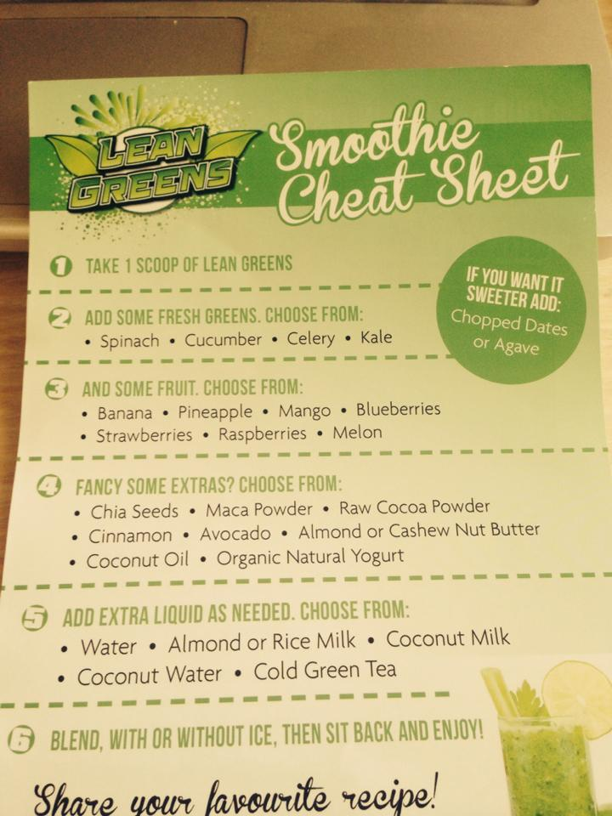
You do not have to use the Lean Greens powder to make the greens drinks. It is one of the few supplements that I recommend to clients especially those who have suffered with low energy, poor skin quality and poor digestive efficiency. But hey use this sheet to help you formulate your own drink.

My recommendation is not to add Agave though as this is very high in fructose, a sugar that the body cant utilise very effectively.

Also don’t use (natural yoghurt) on every occasion if your goal is to really smash belly fat. It would be ok post training from time to time but you are better off with the other options.

4 Tips To Help With Sugar Cravings?

Without going to deep into the science behind glucose tolerance and blood sugar regulation, I just wanted to let you know of a few very simple things that I found successful with my clients when we trialled a few things.

Unfortunately in the modern society of highly processed foods, there is an ever-increasing dependency on sugar and an increase in diseases associated with this problem.

The problem really lies with the most refined products such as white flour and other products made from them, cakes, biscuits, breads.

Unfortunately weight doesn’t tell the whole story either its really just as dangerous to be what is known as a ‘skinny fat person’. You may well know this person, they eat crap and still don’t look fat. Well that’s on the outside, chances are that their organs are surrounded by fat laid down to protect them from the toxins they are bombarded with. So playing the gene game, of my parents are skinny will not save them from the cluster of risk factors they are exposing themselves to by frequently indulging in sugar laden and processed products (you cant really call them foods).

Here are 4 things you can start doing today to stop this fast track to the risks associated with excess sugar and a dependency on it.

- Start moving more- by doing this even in short bursts, at work, at home wherever, encourage your liver to release some of the stored glycogen for use and expenditure. Intervals are excellent at this, hence why I have been getting you to do some of these in your training.

2. Coconut Oil-

If you have a slightly sluggish metabolism, coconut oil is for you!! You should already be using this in recipes for cooking.
It is worth noting the role of coconut oil in the suppression of Candida. Candida is yeast (fungus) that lives in our gut. Normally, this will do little harm as our probiotic bacteria deal with it. But, when we consume antibiotics, toxic foods or suffer daily stress, the Candida thrives, leading to many symptoms including weight retention and infections.

Coconut Oil contains a lot of medium chain fatty acids which help to fire up the fat burning furnace that is your metabolism. These medium chain fatty acids are responsible for the Herxheimer reaction. This reaction is one that rapidly kills yeast toxins and Candida.

The Lauric acid in coconut oil, which is only found in mother's milk otherwise, is a great source of antimicrobial and anti viral properties, aiding your immune support system. It has been found that by eating one teaspoon of coconut oil per day that you can boost your metabolism by up to 48%! That is amazing!

3. Cinnamon-

This has been found to contain a type of antioxidant that increases insulin sensitivity, and helps to stabilize blood sugar, which means you'll store less fat. Bonus. Load up with a teaspoon of this in your diet each day by adding it to oats, pancakes, drinks (smoothies with protein and alkaline vegetables) , or anything else!

4. Magnesium

As we exercise more, our bodies use more magnesium so this is the time to add this into your supplemental plan. This is another mineral that helps with glucose transport and insulin sensitivity. I also love to use this one to help prevent sugar cravings and it's a natural muscle relaxant. Go to the health food shop and ask them for any of the magnesium’s that finish with “ate”. Do not get the oxide versions, as they are not very well absorbed by the body. Take this two hours before bed and it will also help with sleep.

Ok so there you go. 4 Very simple steps to help you with those sugar cravings.

Matt

