Day 1 | Day 2 | Day 3 | Day 4 | Day 5 | Day 6 | Day 7
BREAKFAST  Post Training Meal / Non Training Meal | BREAKFAST  Intermittent fast or if you really cant manage it go for the any meal given so far. | BREAKFAST  Post Training Meal / Non Training Meal | BREAKFAST  The 3 egg surprise (detox book) | BREAKFAST  Post Training Meal / Non Training Meal | BREAKFAST  Any smoothie.  Cooked meats/fish with a spice on it. | BREAKFAST  Intermittent fast or if you really cant manage it go for the any meal given so far.
Berry Choice + Nut/seed (optional) | Berry Choice + Nut/seed (optional) | Fruit Choice + Nut/seed (optional) | Berry Choice + Nut/seed (optional) | Berry Choice + Nut/seed (optional) | Fruit Choice + Nut/seed (optional)
GREEN DRINK OR SNACK | GREEN DRINK OR SNACK | GREEN DRINK OR SNACK | GREEN DRINK OR SNACK | GREEN DRINK OR SNACK | GREEN DRINK OR SNACK | GREEN DRINK OR SNACK
LUNCH  3 vegetables – ideally 2 raw. Protein source  Fat source  Good Carb | LUNCH  3 vegetables – ideally 2 raw. Protein source  Fat source  Good Carb | LUNCH  3 vegetables – ideally 2 raw. Protein source  Fat source  Good Carb | LUNCH  3 vegetables – ideally 2 raw. Protein source  Fat source  Good Carb | LUNCH  3 vegetables – ideally 2 raw. Protein source  Fat source  Good Carb | LUNCH  3 vegetables – ideally 2 raw. Protein source  Fat source  Good Carb | LUNCH  3 vegetables – ideally 2 raw. Protein source  Fat source  Good Carb
GREEN DRINK OR SNACK | GREEN DRINK OR SNACK | GREEN DRINK OR SNACK | GREEN DRINK OR SNACK | GREEN DRINK OR SNACK | GREEN DRINK OR SNACK | GREEN DRINK OR SNACK
DINNER  Any evening meal that you have enjoyed so far | DINNER  Post Training Meal / Non Training Meal | DINNER  Anything you like from the plan so far. | DINNER  Post Training Meal / Non Training Meal | DINNER  Any evening meal that you have enjoyed so far | DINNER  Anything you like from the plan so far. | DINNER  FREE CHOICE- yep today is a free choice…if you want roast potatoes and gravy, then today is the day!!!

Post Training Meal Ideas:

Option 1 : Banana Omelette (from the 30 days of fat loss cookbook). Ideal cooked the night before and eaten at work if you are in a rush.
Option 2: 2-4 eggs scrambled with a bed of spinach
Option 3: banana plus a palm sized portion of meats for the ladies and 2 palms for the men plus a bed of greens
Option 4: almond milk, banana, almond/cashew butter (tablespoon), spinach and berries in a smoothie.

Non Training Meal (for the times when you haven’t trained)- as per the lunches below or any of the evening meals you have had so far.

Lunches:

These apply to the whole day but this will help you :

Raw Veggies - peppers, celery, cucumber, carrot, avocado and tomatoes (technically fruits). There are many more I am sure but there are a few that will get you going on the raw veggies.
Protein sources- beef, turkey, fish, chicken, game, rabbit, pork (but please know where this was sourced and go for leaner cuts)
Fat Sources- avocado, flaxseed oil (great for salads), brazil nuts, almonds, pumpkin seeds, sunflower seeds
Good Carbs - - oats, quinoa, buckwheat, bulgur wheat, brown rice, wild rice, sweet potato

Greens drink- same format as last week
Fruit choice – berries, cherries, banana and melon (after training), apple with a nut butter on it.
Nuts/seeds choice- same format as last week

Intermittent fast- In simple terms this means eat your evening meal and then just drink your herbal teas, water and take your supplements as prescribed until midday the next day. Then eat as normal there after. I can give you all the science behind it if you want, just let me know.

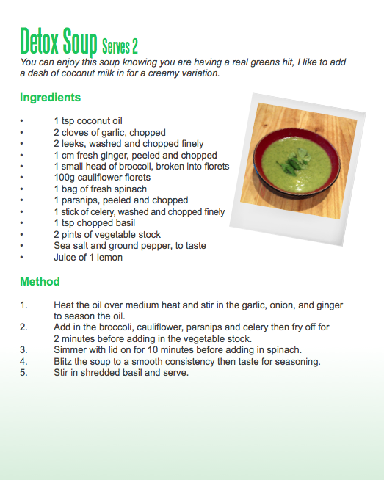

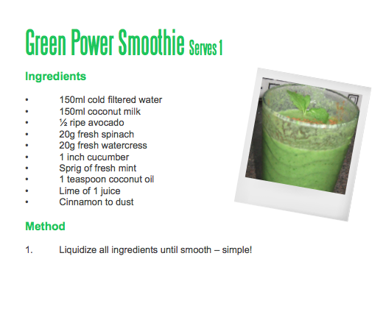
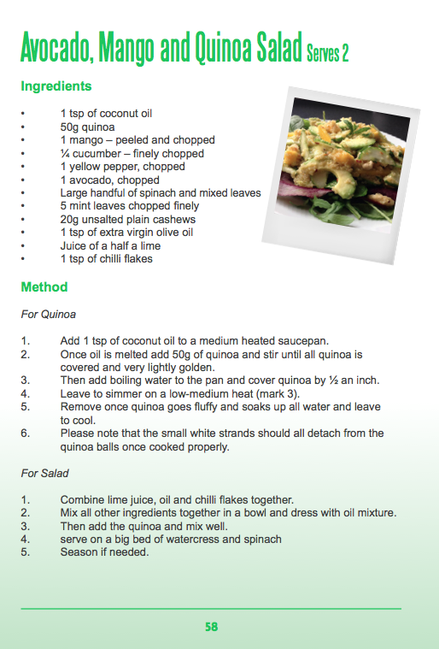
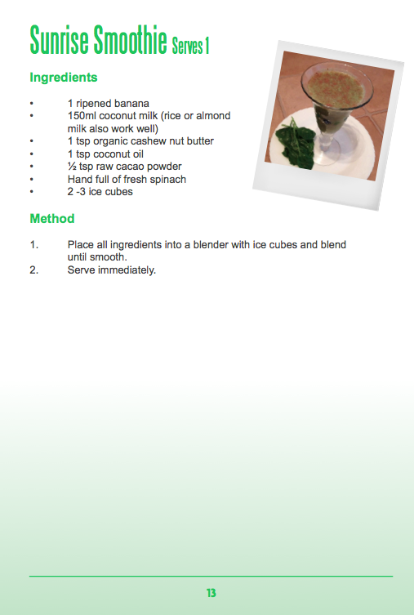
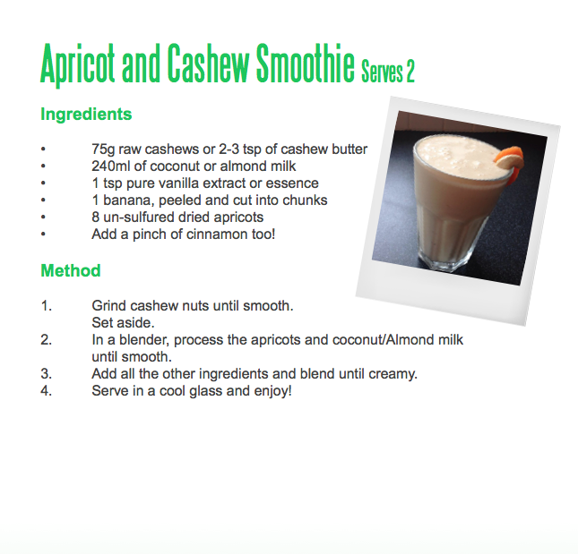
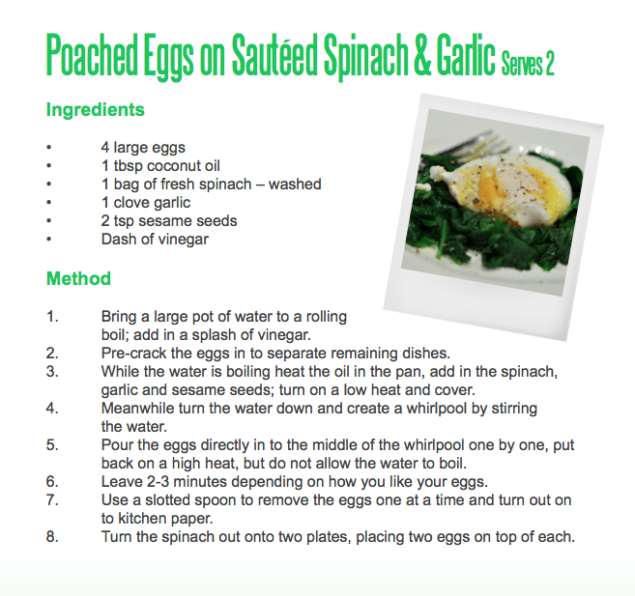
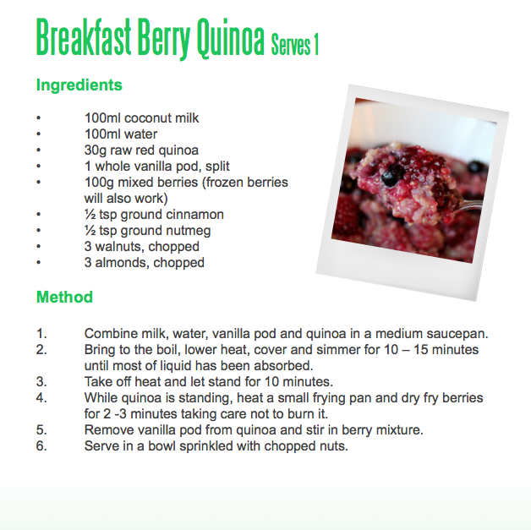
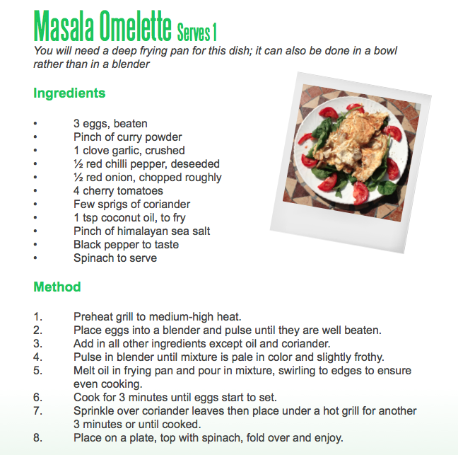

Targeting Areas:

Stomach- its stress related. It comes in all sorts of forms, as you know!!!;)
Avoid citrus fruits this week, obviously sugars (artificial) and stay off grains just to see how it helps you (it normally does). Add beetroot, olives, avocados, and more oily fish.
Add liquorice tea, its excellent at re-dressing the hormone imbalance that has occurred to make you store fat around the middle.

Bra Strap- again just stick with veggies as your carb source and foods high in fibre.

Back of the arms- get yourself in the sauna, this is an excellent way to speed up the detox and a lot of the toxins that build up tend to stick around the alpha fat cells which there are many on the back of the upper arm.

Love Handles- I want you to lie down for 15 minutes per day, in absolute silence. It can be done, even with children, I have had parents do this before.

I want you to keep your fruit to in and around exercise.
Drink Green tea.
Eat pumpkin seeds and choose lean beef.
Use cinnamon to help regulate blood sugar levels.

